Lab4

Create one more bucket

* Bucket name old bucket name followed by replica keyword for identification purpose

Example:

My old bucket name “amit23bucket” , new bucket name I will give” amti23bucket-replica”

* Enable the versioning
* Now go to source bucket and click on management

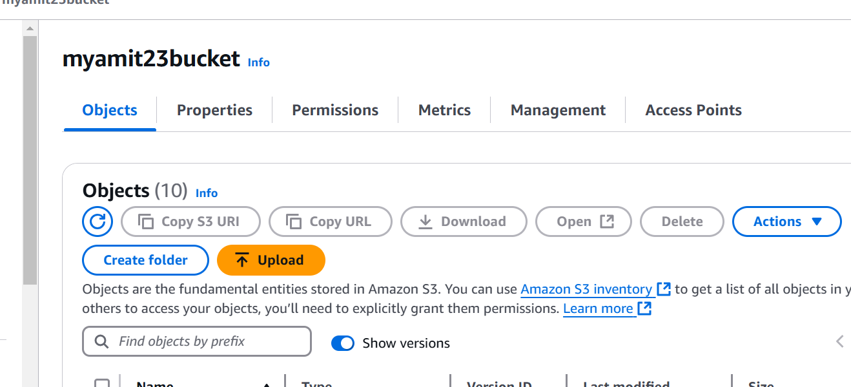

Click on replication rules

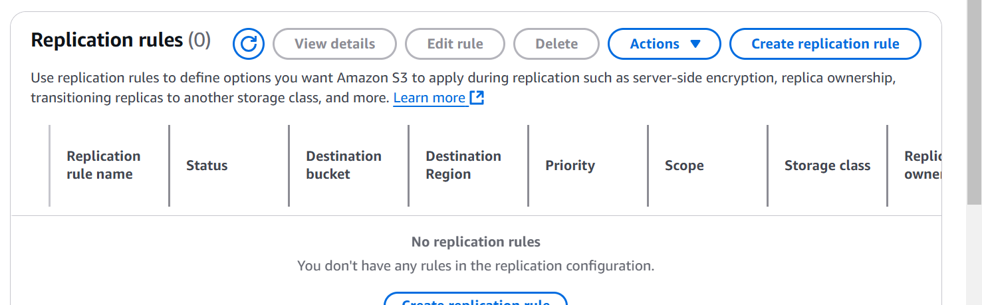

Provide a name

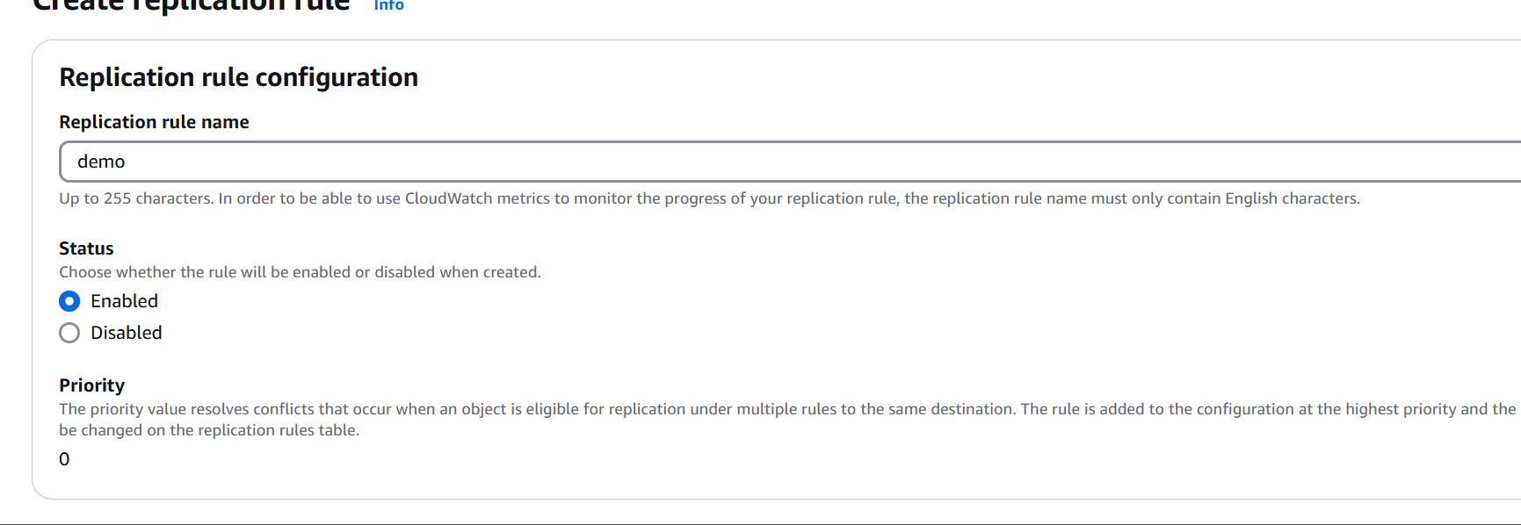

On source bucket section, apply to all the resources

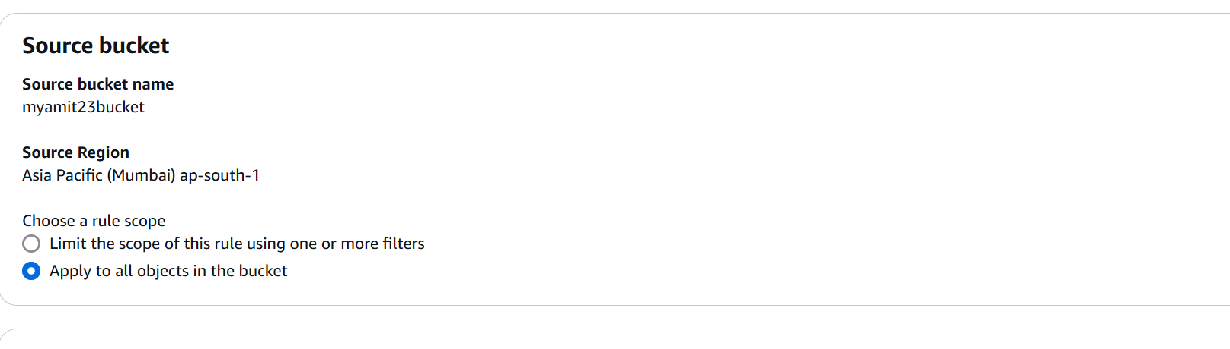

Select the destination bucket

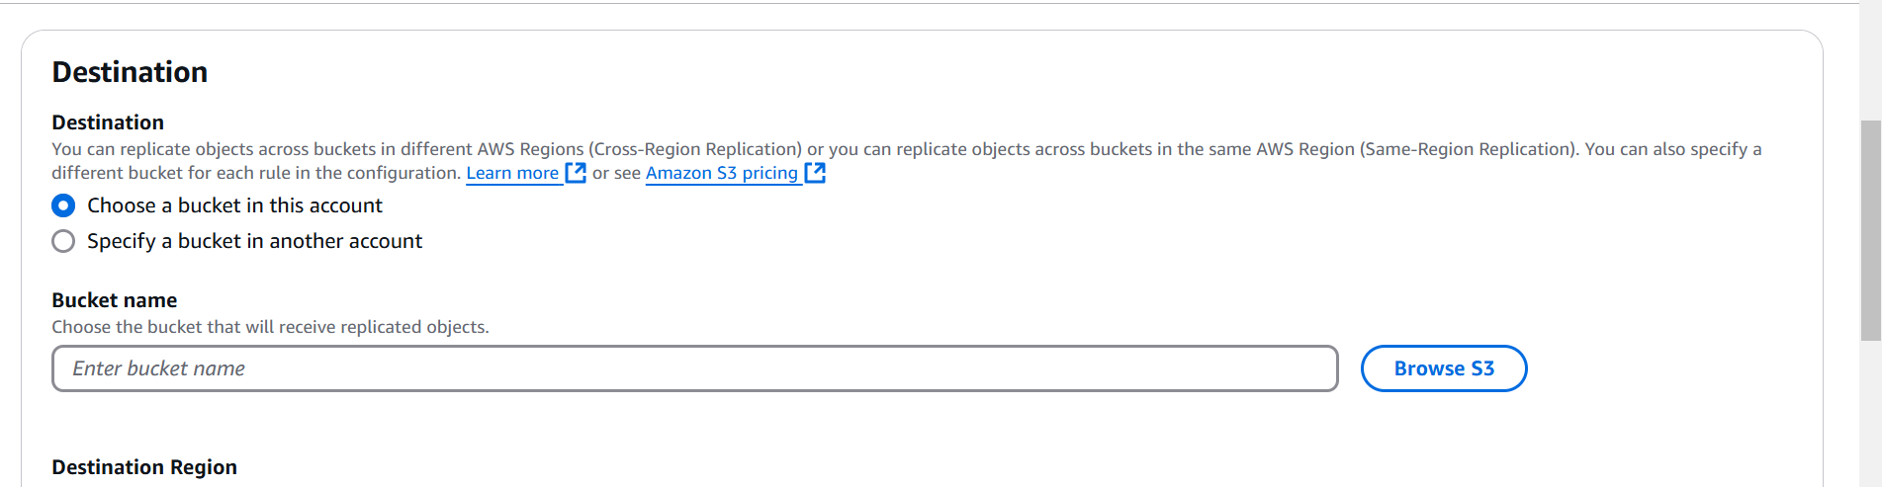

Create new Iam rule

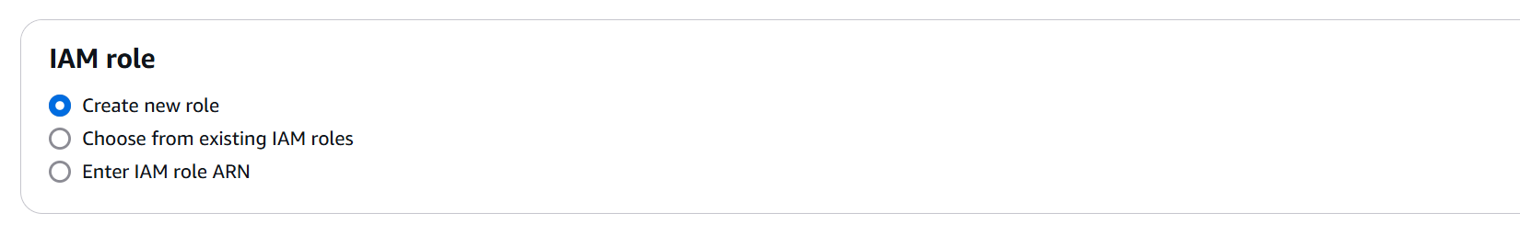

You will get a prompt

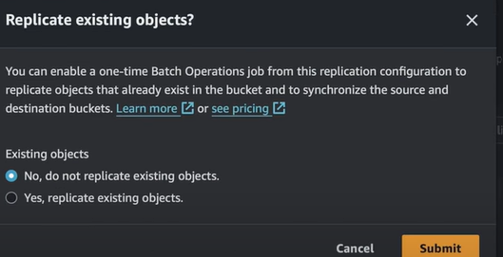

Job option

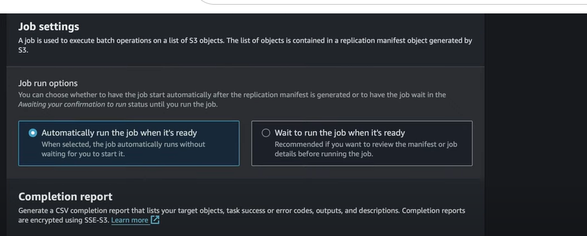

Go in replica bucket and check the contents after some time